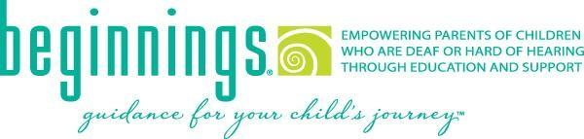

**Professional Recommendation**

|  |  |
| --- | --- |
| __________________________________________ | __________________________________________ |
| Name | Title/organization |
| __________________________________________ | __________________________________________ |
| Address | Phone number |
| __________________________________________ | __________________________________________ |
| Relationship to family | How long have you known the family? |
| _________________________________________ | __________________________________________ |
| Name of child | Name of parent/guardian |

Please rate the following statements:

The family has demonstrated commitment to their chosen communication mode or language for their child: Strongly agree Somewhat agree Somewhat disagree Strongly disagree Not applicable

The family has demonstrated commitment to the use of appropriate amplification:

Strongly agree Somewhat agree Somewhat disagree Strongly disagree Not applicable

The family has consistently attended appointments/therapies:

Strongly agree Somewhat agree Somewhat disagree Strongly disagree Not applicable

The family has demonstrated an understanding of the importance of consistent follow-through of recommendations outside of therapy settings:

Strongly agree Somewhat agree Somewhat disagree Strongly disagree Not applicable

Please provide any additional information to support the above ratings:

_________________________________________________________________________________________

__________________________________________________________________________________________

______________________________________________________________________________________ __

__________________________________________ __________________________________________

Signature Date

Please return via email, fax or mail to [raleigh@ncbegin.org](mailto:raleigh@ncbegin.org), (919) 715-4093 or 156 Wind Chime Court, Suite A, Raleigh, NC 27615